

Write your name below:

SOLUTIONS

_______________________________________________

**Hale School**

**Year 11 Semester 1 Examination, 2017**

**Mathematics   
Methods**

**Circle your teacher**

**VMU MPC IFB MS SAV BAH**

**Section Two:  
Calculator-assumed  
  
Booklet 2 of 3**

­­­­­­­­­

46

TIME ALLOWED FOR THIS SECTION

Reading time before commencing: Ten minutes  
Working time for paper: One hundred minutes

**MATERIAL REQUIRED/RECOMMENDED FOR THIS PAPER**

*TO BE PROVIDED BY THE SUPERVISOR*

**TWO** Question/Answer booklets for Section Two – complete BOTH.

Formula Sheet (retained from Section One).

*TO BE PROVIDED BY THE CANDIDATE*

*Standard Items*: pens (blue/black preferred), pencils (including coloured), sharpener,   
 correction fluid/tape, eraser, ruler, highlighters

*Special Items*: drawing instruments, templates, notes on two unfolded sheets of A4 paper, and   
 calculators approved for use.

**IMPORTANT NOTE TO CANDIDATES**

No other items may be taken into the examination room. It is your responsibility to ensure that you do not have any unauthorised notes or other items of a non-personal nature in the examination room. Please check carefully, and if you have any unauthorised material with you, hand it to the supervisor **BEFORE** reading any further.

**STRUCTURE OF THIS PAPER**

|  |  |  |  |  |  |
| --- | --- | --- | --- | --- | --- |
| Section | Number of questions available | Number of questions to be answered | Working time (minutes) | Marks available | Percentage of exam |
| Section One:  Calculator-free | 10 | 10 | 50 | 53 | 35 |
| Section Two:  Calculator-assumed | 13 | 13 | 100 | 88 | 65 |
|  | | |  | **Total** | 100 |

**INSTRUCTIONS TO CANDIDATES**

1. Write your answers in this Question/Answer Booklet.
2. You must be careful to confine your responses to the specific questions asked and to follow any instructions that are specific to a particular question.
3. Spare pages are included at the end of this booklet. They can be used for planning your responses and/or as additional space if required to continue an answer.

● Planning: If you use the spare pages for planning, indicate this clearly at the top of the page.

● Continuing an answer: If you need to use the space to continue an answer, indicate   
 in the original answer space where the answer is continued, i.e. give the page number.

Fill in the number of the question that you are continuing to answer at the top of the page.

1. Show all your working clearly. Your working should be in sufficient detail to allow your answers to be checked readily and for marks to be awarded for reasoning. Incorrect answers given without supporting reasoning cannot be allocated any marks. For any question or part question worth more than two marks, valid working or justification is required to receive full marks. If you repeat any question, ensure that you cancel the answer you do not wish to have marked.
2. It is recommended that you do not use pencil, except in diagrams.

Section Two: Calculator Assumed   
This section has 13 questions. Answer all questions. Write your answers in the spaces provided.  
Working time: 100 minutes  
_______________________________________________________________________________

**1. [5 marks]**

The diagram shows parts of the graphs of  and **

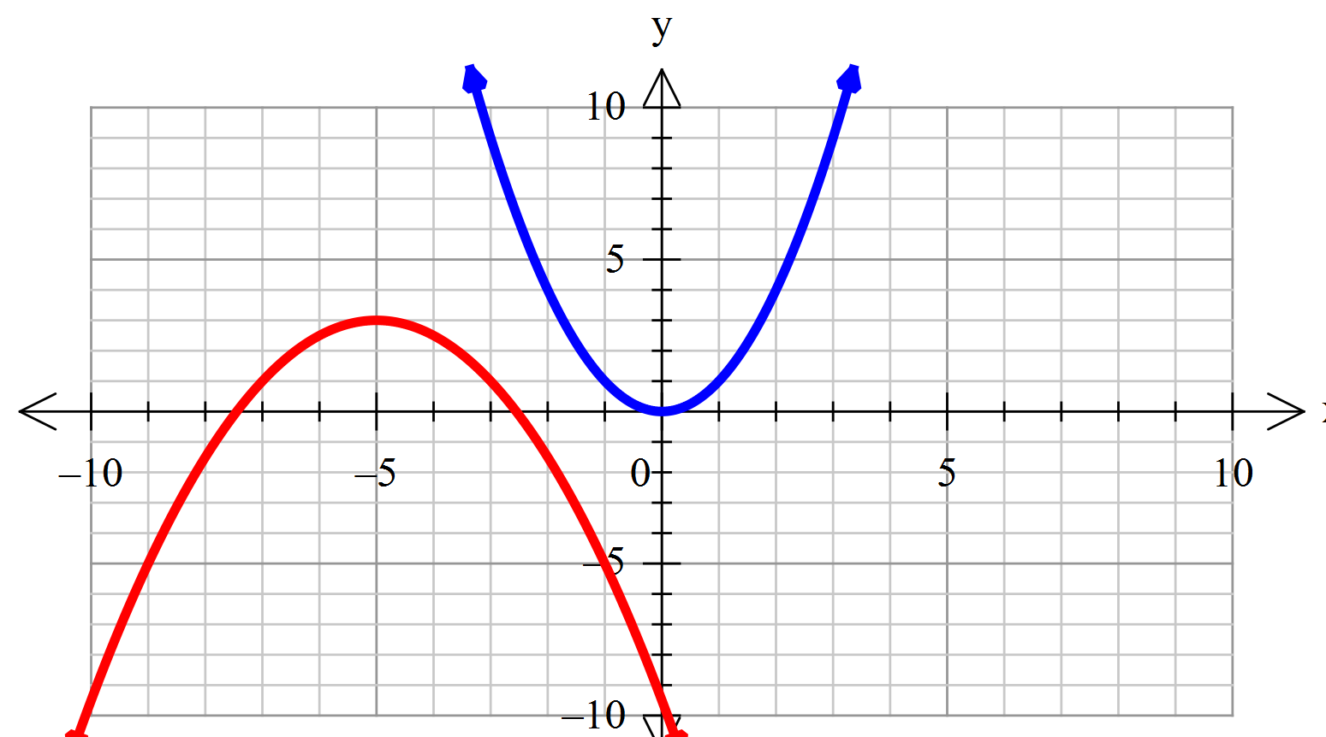

The graph of may be transformed into the graph of**by four transformations.

Describe the transformations in the correct order.

|  |  |
| --- | --- |
| **Solution** | **Specific Behaviours** |
| 1. Vertical dilation of 2. Reflection about the 3. Horizontal translation  units to the left 4. Vertical translation units up | * Vertical dilation * Refection * Horizontal translation * Vertical translation * Order of Transformations |

1. **[2, 2 = 4 marks]**

Find the radius and centre of the circles given by the equations below:

(a) 

|  |  |
| --- | --- |
| **Solution** | **Specific Behaviours** |
|  | * Correct centre * Correct Radius |

(b) 

|  |  |
| --- | --- |
| **Solution** | **Specific Behaviours** |
|  | * Correct centre * Correct Radius |

**3. [2, 2, 2, 2, 2 = 10 marks]**

For the functions 

,  



(a) State the natural domain and the corresponding range for each of the following:

(i) 

|  |  |
| --- | --- |
| **Solution** | **Specific Behaviours** |
|  | * Correct domain * Correct range |

(ii) 

|  |  |
| --- | --- |
| **Solution** | **Specific Behaviours** |
|  | * Correct domain * Correct range |

(iii) 

|  |  |
| --- | --- |
| **Solution** | **Specific Behaviours** |
|  | * Correct domain * Correct range |

(b) Determine 

|  |  |
| --- | --- |
| **Solution** | **Specific Behaviours** |
|  | * Correct Method used to calculate function values * Determines correct value |

(c) Solve for *p* if 

|  |  |
| --- | --- |
| **Solution** | **Specific Behaviours** |
|  | * Correct Method used to solve * Determines correct value for |

**4. [2, 2, 3 = 7 marks]**

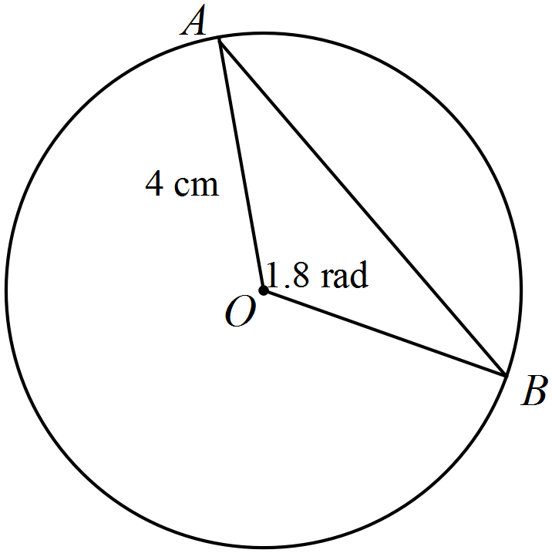For the circle below, find:

1. the length of the minor arc *AB*

|  |  |
| --- | --- |
| **Solution** | **Specific Behaviours** |
|  | * Substitute correct values into correct formula * Determines correct value   Penalty for units for units on this question ONLY |

1. the area of the minor sector *OAB*

|  |  |
| --- | --- |
| **Solution** | **Specific Behaviours** |
|  | * Substitute correct values into correct formula * Determines correct value |

(c) the area of the major segment formed by the chord *AB*

|  |  |
| --- | --- |
| **Solution** | **Specific Behaviours** |
|  | * Method used to calculate the area correctly. * Substitute correct values into correct formulas * Determines correct value |

**5. [3, 3, 1, 2 = 9 marks]**

The function  has been graphed below, the asymptotes are shown.

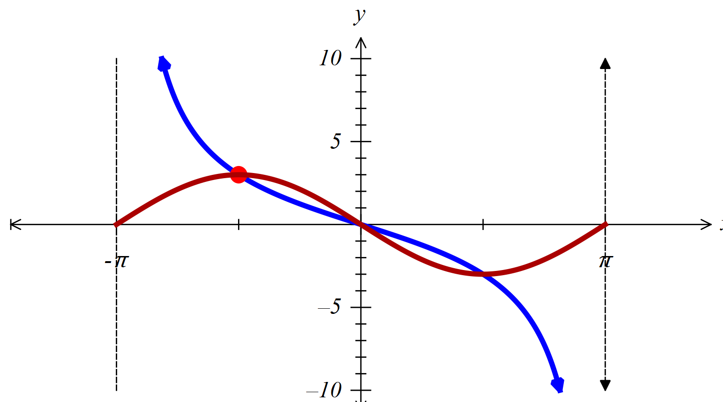

$$\left(-\frac{π}{2},3\right)$$

1. Determine the values of the constants  and .

|  |  |
| --- | --- |
| **Solution** | **Specific Behaviours** |
|  | * Correct b-value * Substitute 1 point and calculated * Determines correct value for |

1. On the axes above sketch .

|  |  |
| --- | --- |
| **Solution** | **Specific Behaviours** |
|  | * 2 points * Period * Shape |

1. State how many times over the domain .

|  |  |
| --- | --- |
| **Solution** | **Specific Behaviours** |
|  | * States correct amount |

(d) Solve , , giving your answer in 4 significant figures.

|  |  |
| --- | --- |
| **Solution** | **Specific Behaviours** |
| Screen Clipping | * Correct stated |

**6. [3, 1, 1 = 5 marks]**

The depth of water, , at the end of the Busselton Jetty, hours after low tide is given by the rule:



The first low tide occurs at 4am , when the depth is 2 metres. At high tide, which occurs 8 hours later, the depth is 6 meters.

1. Sketch the graph of the above function for 

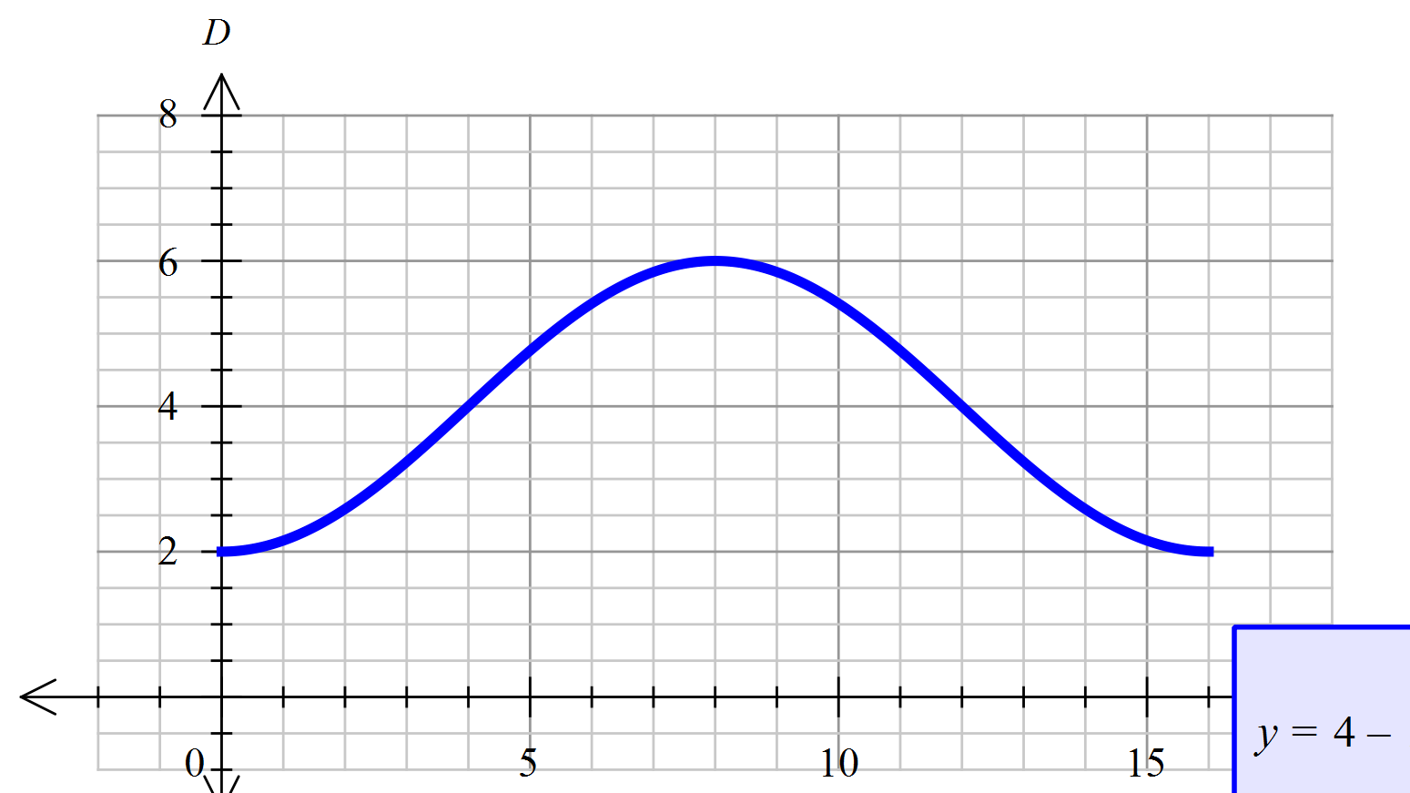

|  |  |
| --- | --- |
| **Solution** | **Specific Behaviours** |
|  | * 2 points * Period * Shape |

1. If the first low tide occurs at 4am when will the next low tide occur?

|  |  |
| --- | --- |
| **Solution** | **Specific Behaviours** |
|  | * Correct time stated |

1. The poles at the end of the Busselton Jetty stand 7.5 m above the sea bed. How much will a particular pole be exposed at **high tide**?

|  |  |
| --- | --- |
| **Solution** | **Specific Behaviours** |
|  | * Correct length stated |

**7. [3, 3 = 6 marks]**

(a) Given that the graph of 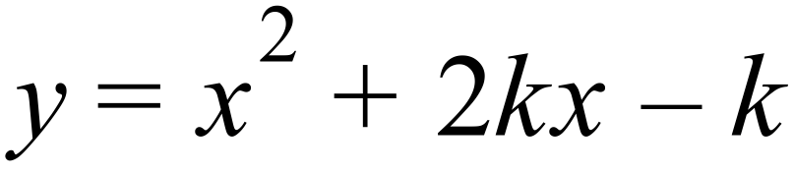 has two $x$-intercepts, determine the possible value(s) of $k$.

|  |  |
| --- | --- |
| **Solution** | **Specific Behaviours** |
|  | * States discriminant is greater than * Substitute given values * Finds correct values for |

(b) Write 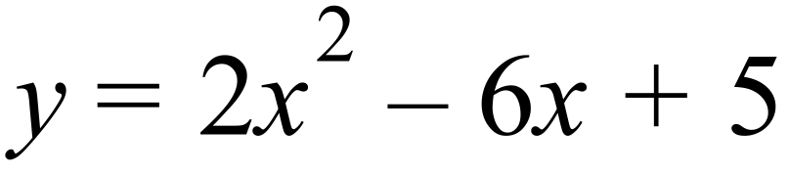 in turning point form by completing the square.

|  |  |
| --- | --- |
| **Solution** | **Specific Behaviours** |
|  | * Factorise (common factor) * Method used to complete the square correctly * Simplify |

**END OF BOOKLET 2**

This page may be used for extra working space:

Question: ______

This page may be used for extra working space:

Question: ______